Kevin Dunn

4511W HW # 3

1. 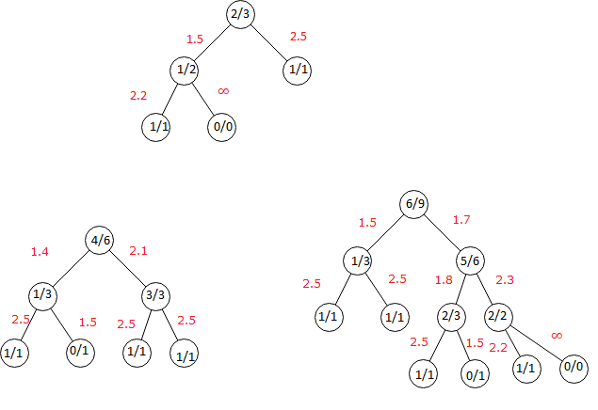

2. (1) no pure Nash equilibrium

(2) Player 1, P = 87.5%

Expected 4.625

Player 2, P = 37.5%

Expected 2.75

(3) (9,1), (2,8)

(4)

3. (1) 0k: {(t = 0 t = 120)}

4k: $\{\left(10≤t≤110\right)\bigwedge{ \left(t >0k_{t}+10\right)\bigwedge{ \left(t >8k_{t}-10\right)}}$}

8k: $\{\left(20≤t≤100\right) \bigwedge{ \left(t >4k_{t}+10\right)\bigwedge{ \left(t > 12k_{t}-10\right)}}\}$

12k: $\{\left(30≤t≤90\right) \bigwedge{ \left(t >8k_{t}+10\right)\bigwedge{ \left(t>16k_{t}-10\right)\}}}$

16k: $\{\left(40≤t≤80\right) \bigwedge{ \left(t>12k_{t}+10\right)}\}$

(2) 0k: {(t = 0 $∨$ t = 120)}

4k: $\{\left(10≤t≤110\right)\bigwedge{ \left(t > 0k_{t}+10\right)\bigwedge{\left(t > 8k_{t}-10\right)∧\left(t≠t+20\right)}}$}

8k: $\left(20≤t≤100\right)\bigwedge{ \left(t>4k_{t}+10\right)\bigwedge{\left(t>12k_{t}-10\right)∧\left(t≠t+20\right)}}$

12k: $\{\left(30≤t≤90\right) \bigwedge{ \left(t>8k_{t}+10\right)\bigwedge{ \left(t>16k_{t}-10\right) ∧(t ≠t + 20)\}}}$

16k: $\{\left(40≤t≤80\right) \bigwedge{ \left(t>12k_{t}+10\right) ⋀ (}¬50 ∨¬60) ∧(t ≠t + 20)\}$

(3) 0k: {0, ~~10, 20, 30, 40, 50, 60, 70, 80, 90, 100, 110,~~ 120}

4k: {~~0~~, 10, 20, 30, 40, 50, 60, 70, 80, 90, 100, 110, ~~120~~}

8k: {~~0~~, 10, 20, 30, 40, 50, 60, 70, 80, 90, 100, 110, ~~120~~}

12k: {~~0~~, 10, 20, 30, 40, 50, 60, 70, 80, 90, 100, 110, ~~120~~}

16k: {~~0~~, 10, 20, 30, 40~~, 50, 60~~, 70, 80, 90, 100, 110, ~~120~~}

(4) 0k: {0, ~~10, 20, 30, 40, 50, 60, 70, 80, 90, 100, 110,~~ 120}

4k: {~~0~~, 10, 20, 30, 40, 50, 60, 70, 80, 90, 100, 110, ~~120~~}

8k: {~~0, 10,~~ 20, 30, 40, 50, 60, 70, 80, 90, 100, ~~110, 120~~}

12k: {~~0, 10, 20, 30,~~ 40, 50, 60, 70, 80, 90~~, 100, 110, 120~~}

16k: {~~0, 10, 20, 30,~~ 40, ~~50, 60~~, 70, 80~~, 90, 100, 110, 120~~}

(5) 0k: {0, ~~10, 20, 30, 40, 50, 60, 70, 80, 90, 100, 110,~~ 120}

4k: {~~0~~, 10, 20, 30, 40, 50, 60, 70, 80, 90, 100, 110, ~~120~~}

8k: {~~0, 10,~~ 20, 30, 40, 50, 60, 70, 80, 90, 100, ~~110, 120~~}

12k: {~~0, 10, 20, 30,~~ 40, 50, 60, 70, 80, 90~~, 100, 110, 120~~}

16k: {~~0, 10, 20, 30, 40, 50, 60~~, 70, 80~~, 90, 100, 110, 120~~}

(6)

|  |  |  |  |  |  |  |  |  |  |  |  |  |  |
| --- | --- | --- | --- | --- | --- | --- | --- | --- | --- | --- | --- | --- | --- |
| Time | 0 | 10 | 20 | 30 | 40 | 50 | 60 | 70 | 80 | 90 | 100 | 110 | 120 |
| Height | 0k | 4k | 8k | 12k | 12k | 12k | 12k | 16k | 16k | 12k | 8k | 4k | 0k |

4. At each level there are $2^{d}$ nodes. On each level you can eliminate 1 branch out of every pair except for the first 2 branches on each level. This means you can eliminate $\frac{2^{d-1}-1}{2^{d}}$ branches from each level. There are d levels in a tree, so .

5. (1) 10 cheaters 15 simpletons

(2)

|  |  |  |  |  |  |  |  |  |  |  |  |
| --- | --- | --- | --- | --- | --- | --- | --- | --- | --- | --- | --- |
| Mistake | 0% | 5% | 10% | 15% | 20% | 25% | 30% | 35% | 40% | 45% | 50% |
| Dominant | S | S | C | C | C | C | C | C | C | C | C |